Configuration Stapling-/Nailing-Machine

Company: |  | Phone:
Street: |  | Fax:
Postal Code/Location: |  | E-Mail:
Country:
Contact: |  | Department:

Please complete the questionnaire. Not all fields have to be completed.

Category
☐ Stapling  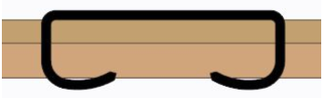  Material 1  Material 2 | 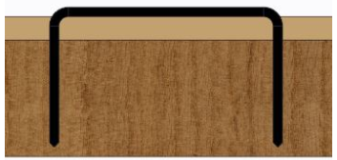  ☐ Nailing  Material 1  Material 2

Material
Material 1: | ☐ carton |  | ☐ plastic |  |  | ☐ wood |  | ☐ others:
Material 2: | ☐ carton |  | ☐ plastic |  |  | ☐ wood |  | ☐ others:
☐ Solid board |  |  |  |  |  |  | If known, indicate strength or FEFCO No.
☐ Single corrugated board
☐ Double corrugated board |  |  |  | 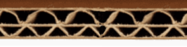
☐ Triple corrugated board |  |  |  | 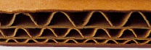
☐ Material thickness: |  | Material 1 (mm): |  |  |  | Material 2 (mm):
☐ Material layers: |  | ☐ single |  |  | ☐ double | ☐ triple |  |  | ☐ -fold
☐ Staple position/s
Sketch with indication of staple position/s; for each size one sketch under point P).
(Please send pictures and samples!)

Version

☐ Folding boxes | ☐ Telescope cartons |  | ☐ Cardboard trays
☐ Other cardboard boxes  (please define exactly under P) or/and insert pictures) |  | ☐ Other articles  (please define exactly under P) or/and insert pictures)

Type of Closure
☐ Bottom closure  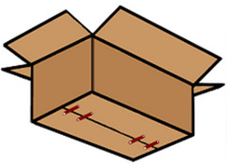 | ☐ Top closure  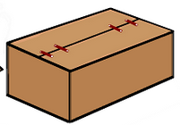 | ☐ Bottom/top tray  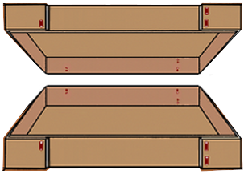
☐ Other articles
(please define exactly under P) or/and insert pictures)

Carton with content
Weight: | kg
Content:

Sizes
☐ Carton  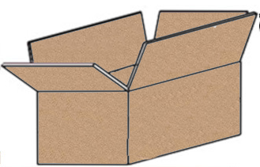  K3  L  H  B  K2  K1 | ☐ Tray  Flap folding:  1) ☐ outside 2) ☐ inside  2  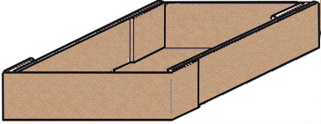  L  H  1  B | ☐ Others  (please specify  under P)  ?

Part designation | Carton/tray |  |  | Carton/top/bottom
 | L  in mm | B  in mm | H  in mm | K1  in mm | K2  in mm | K3  in mm

Workflow
Process |  |  |  | Comment
☐ Unfold cardboard | ☐ manual | ☐ automatic
☐ Fold carton bottom | ☐ manual | ☐ automatic
☐ Filling the carton | ☐ manual | ☐ automatic
☐ Fold carton lid | ☐ manual | ☐ automatic
☐ simultaneous bottom and lid closure of the filled folding box | ☐ first close the bottom of the empty folding box, then fill the folding box then close the lid of the filled folding box  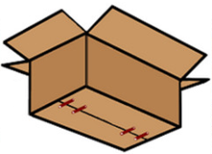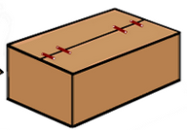 |  | ☐ Define other sequence under P)

Staple material/size
Material: | ☐ Steel, copper plated |  | ☐ Steel, galvanised |  |  | ☐ Stainless steel |  | ☐ other:
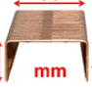  Crown size: |  | ☐ 9 mm  For stapling and nailing |  | ☐ 13 mm  For stapling and nailing | ☐ 20 mm  For stapling and nailing |  | ☐ 36 mm  For stapling |  | ☐ other:

Number of staples
pcs. per | ☐ Bottom | ☐ Top | ☐ Flap | ☐ Side | ☐ other:

Working capacity/cycle number
Quantity: pcs. | ☐ minute | ☐ hour | ☐ other:

Design
☐ mobile | ☐ fix location
☐ free-standing | ☐ integrate into existing line  (please specify)

Degree of automation
☐ mechanical version
(manual)
☐ Semi-automatic (manual insertion/removal)
(pneumatic or electro-pneumatic version)
☐ Fully automatic operation
(electro-pneumatic version)

Adjustment to other sizes
Article sizes come | ☐ chaotically  (different sizes one after the other) | ☐ in series pieces  (same size one after the other)

Stapling machine should be adjusted to the different sizes:
☐ manuell | x per | ☐ shift | ☐ day | ☐ other:
☐ automatic

Requested delivery date
Calendar week/year:

Special internal company rules (specifications)
☐ none | ☐ yes, please send documents

Notes/sketches/other information

☐ I hereby agree that my personal data are stored.
To delete your data, please contact us under info@mezger.eu
Please sent samples of the different sizes, so that we can determine the correct staple.
Please return the completed questionnaire to:
MEZGER Heftsysteme GmbH  Saganer Staße 24  D-90 475 Nürnberg  Germany | Mail: info@mezger.eu  Tel.: +49 (0)911 98494 0  Fax: +49 (0)911 98494 30
Thank you for your efforts
Ihr MEZGER-Team
Copyright© by MEZGER Heftsyteme GmbH, Nürnberg, Germany

